KOPIM SCRIPT

Client: Katie Dow
Date: 5/2/25
Version: 1

KOPIM | DIGITAL SHELF

AUDIO/VO | # | VISUALS
Narrator (Voiceover):  "When consumers are faced with a choice, they expect and need the right information to inform their decision-making immediately, at their fingertips. Transparency, clarity, and accuracy are key. This is the power of KO PIM."  Can you provide some more options for this statement? | 1 | Scene 1: Consumer in Store  Setting the Stage - Visual Introduction to Data Journey  • Open with a wide shot of a modern grocery store aisle. A consumer (young professional) walks down the aisle.  • The camera follows the consumer as they pause at a product, scanning the QR code on the packaging with their smartphone.  • On the phone screen, we see pop-ups of SmartLabel data, ingredients, marketing copy, and regulatory/legal requirements. These graphics pop on screen digitally around the consumer.  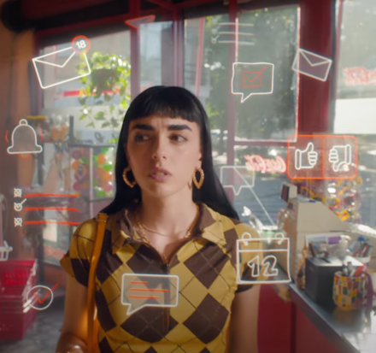
Narrator (Voiceover):  "The decision to purchase is made. Now, let’s follow the product through its data lifecycle." | 2 | • Cut to a close-up of the phone screen, highlighting the information available (SmartLabel, marketing copy, nutritional info, compliance details now on phone).  • The consumer smiles, nodding in satisfaction, and places the product in their basket.  • The camera pulls back to reveal the consumer walking to the checkout line.
Narrator (Voiceover):  "From the checkout counter, the data doesn't stop. It travels through multiple systems, touching every step of the journey. This is where KO PIM, the backbone of our global data model, ensures everything is synchronized and streamlined." | 3 | Scene 2: Transition to Store Clerk - Data Ripple Effect  Exploring Data Flow Backwards  • The consumer proceeds to the checkout counter.  • The cashier scans the barcode of the product.  • On-screen, we show a data “ripple” effect as we transition from in-store, zooming into the barcode information -- visually showcasing data as it travels along a journey from the store to the previous stages of the supply chain.
Narrator (Voiceover):  "From the shelf back to the bottler, details such as product specifics, inventory, andforecasts.are connected by data elements from KO PIM. KO PIM collects, centralizes, and ensures that accurate data flows from our systems into the hands of bottlers and partners, driving transactions." | 5 | • We transition to a delivery truck pulling into a bottler’s warehouse, unloading products.  • Data streams continue, showcasing decision making and bottlers in their workplace.
Narrator (Voiceover):  "KO PIM isn’t just for the Digital Shelf it’s an enabler for brick-and-mortar operations and product commercialization too. By connecting all critical data, it powers tools like Workfront, KOArt, and KO Assets, ensuring that every piece of content, every piece of data, is governed and maintained with precision." | 6 | Scene 3: Bottler Receiving Data from KO PIM  Explaining Bottler Integration and Data Flow  VISUAL:  - Show bottler b-roll (need assets) receiving and interacting with the product data at their warehouse (product packaging, inventory management systems, etc.).  - Show screen recording of how bottlers use KO PIM to access product data and imagery, Include icons or interface visuals of Workfront, KOArt, and KO Assets.
Narrator (Voiceover):  "Data governance is the heart of KO PIM. Clear data ownership, dedicated teams of analysts and stewards ensure the integrity of product data, empowering teams to manage the product lifecycle from creation to the shelf—and beyond." | 7 | • Show the different KO PIM-connected tools (Workfront, KOArt, KO Assets, ISSCOM, KOmply, KO Link) functioning in sync, with data being updated in real time across the different platforms.  • The interface screens of these tools smoothly transition into each other, showing data flowing back into the system.
Narrator (Voiceover):  "KO PIM’s data governance not only supports bottlers and brick-and-mortar but also drives the ecomm experience. Complete and accurate product data combined with digital assets ensures a consistent message for consumers interacting with our products online. This drives informed purchasing decisions, AI-driven recommendations, and data analytics." | 8 | Scene 4: Fast Forward to Ecomm and Digital Shelf  Connecting to Ecomm and Digital Experience  VISUAL:  - Show digital assets, product images, and marketing copy being uploaded onto consumer-facing platforms like Brands.com, customer portals, and Digital Shelf.  - Product images appear on-screen, then transition into a product page with clear data (e.g., product description, nutrition facts, SmartLabel, etc.).
Narrator (Voiceover):  "From product inception to checkout, KO PIM connects, enables, and powers every step of the product lifecycle. This is the future of data, the future of products, and the future of consumer experiences." | 10 | • Close-up of a digital product page showing rich product data (e.g., a high-quality image, detailed descriptions, marketing copy, and customer reviews).  • We transition back to the in-store QR scan and online checkout, tying it all together with seamless data flow across platforms, as we pan up to the customer smiling and walking to exit the store.
Narrator (Voiceover):  "KO PIM—Centralized. Governed. Empowered. Enabling the future of product data." | 11 | Scene 5: Closing Shot and Call to Action  End on KO PIM Branding  VISUAL:  - The KO PIM logo appears on screen.  - Tagline: "KO PIM—Centralized. Governed. Empowered. Enabling the future of product data."
 | 13 | TCCC | KOPIM | DIGITAL SHELF LOGOS

